Read Chapter 9

See if you can translate these questions AND answer them based on what you just read (PRACTICE)

I have included the English translation on the following page in case you want confirmation.

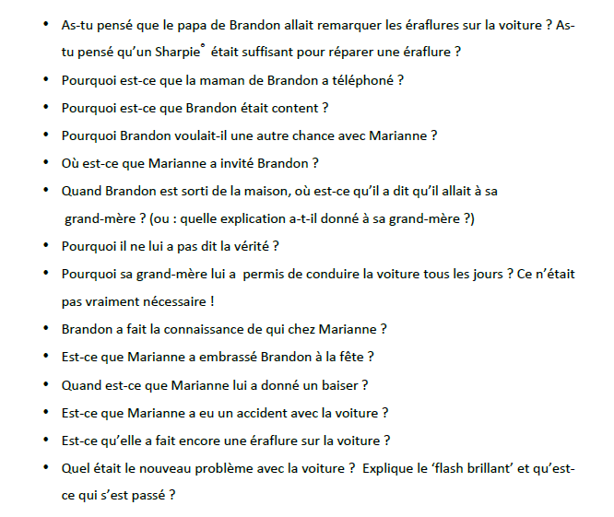

1

2

3

4

5

6

7

8

9

10

11

12

13

14

Scroll down for English translation

1. Do you think Brandon’s dad is going to realize the scratch on the car? Do you think that the Sharpie is going to be sufficient in order to repair the scratch?
2. Why did Brandon’s mom call?
3. Why was Brandon happy?
4. Why did Brandon want another chance with Marianne?
5. To where did Marianne invite Brandon?
6. When Brandon left the house, where did he tell his grandmother that he was going?
7. Why did he not tell her the truth?
8. Why did he grandmother allow him to drive the car each day when it was not really necessary?
9. Whom did Brandon meet at Marianne’s house?
10. Did Marianne kiss Brandon at the party?
11. When did she give him a kiss?
12. Did Marianne have an accident in the car?
13. Did she scratch the car again?
14. What is the new problem with the car? Explain “flash- brilliant” and what happened.

Con’t for crossword puzzle practice

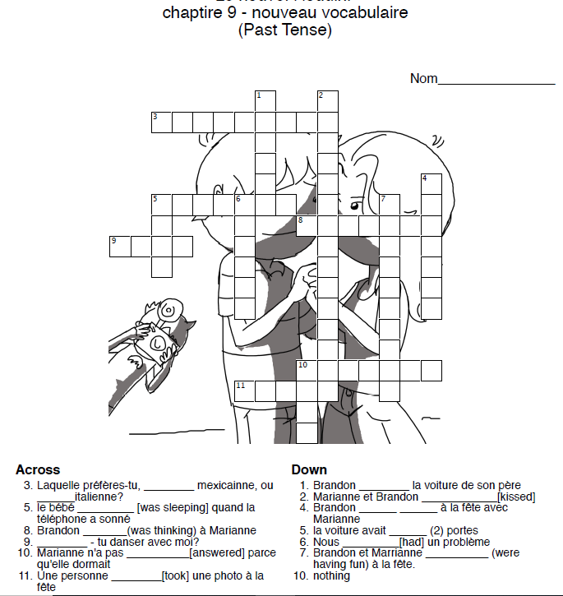

How did you do??????????? Scroll down to check your answers!

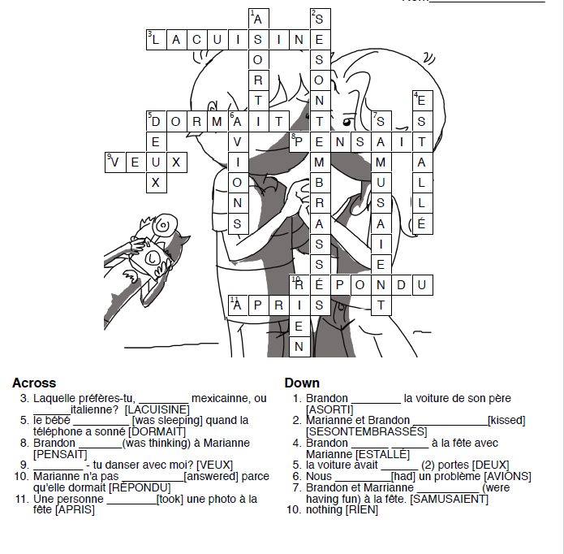

Scroll down for items and ideas to create category grid (which needs to be completed in TEAMS!) Feel free to print these and cut them up for practice in order to easily complete assignment.

